How to Fill Out Felician’s Graduate Application:

- Select Returning Users to log back in or select First-time users to create your account:


- Start New Graduate Application:


- For Summer 2026, select the 2025-26 Felician University Application. For Fall 2026, Summer 2026, and Spring 2027, select the 2026-2027 Felician University Application select Graduate, and then Create Application:

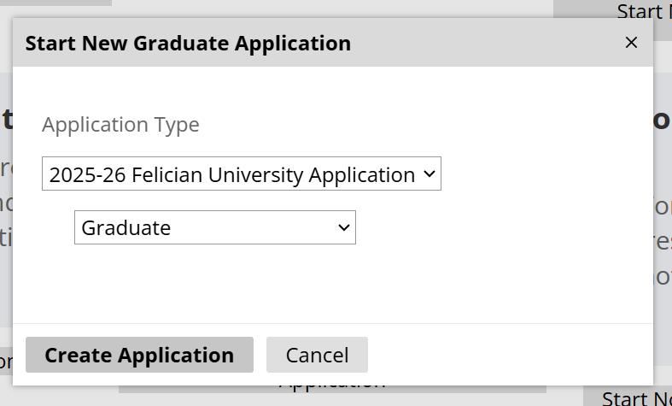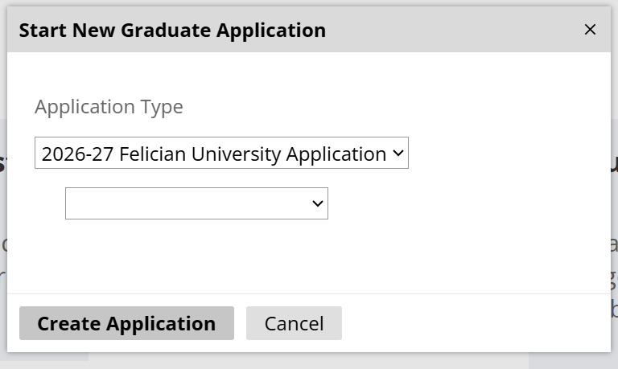

- Fill out the Biographical Information section, and then Continue:
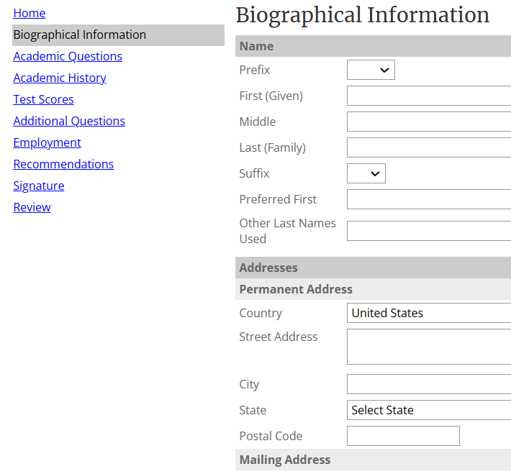

- Fill out the Academic Questions section, and then Continue:
  - Apply as a Full-time Graduate student
  - The application only displays the On Campus Lodi/Rutherford option, but all coursework is offered Online. Please select On Campus Lodi/Rutherford with the understanding that your courses will be Online.
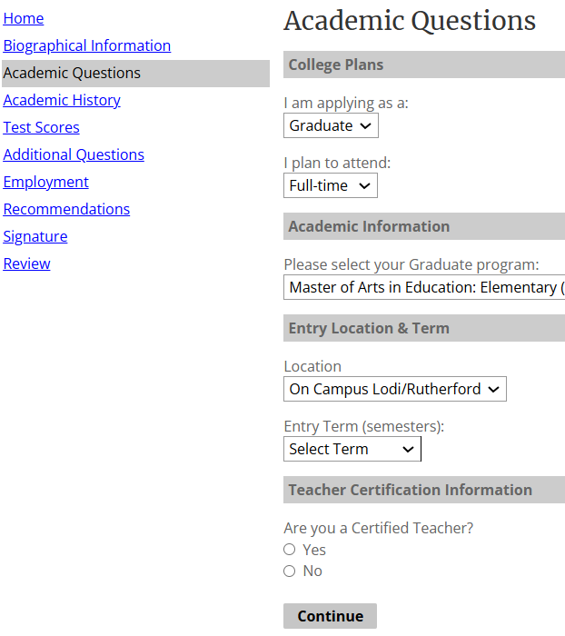

- Fill out the Academic History section, and then Continue:
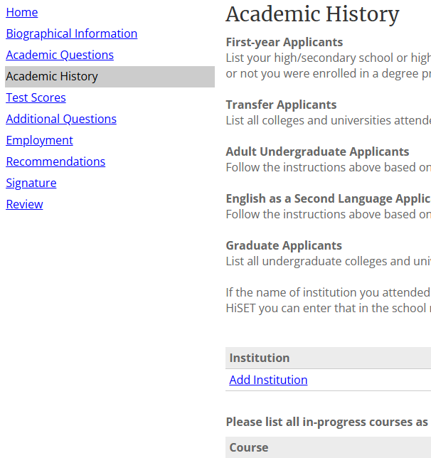

- Fill out the Test Scores section, and then Continue (not required for all programs):
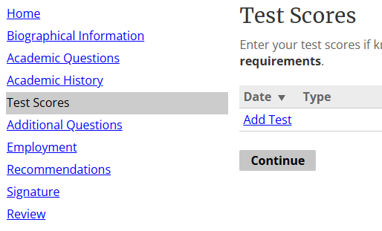

- Fill out the Additional Questions section, and then Continue:
  - Enter application fee waivers in this section.
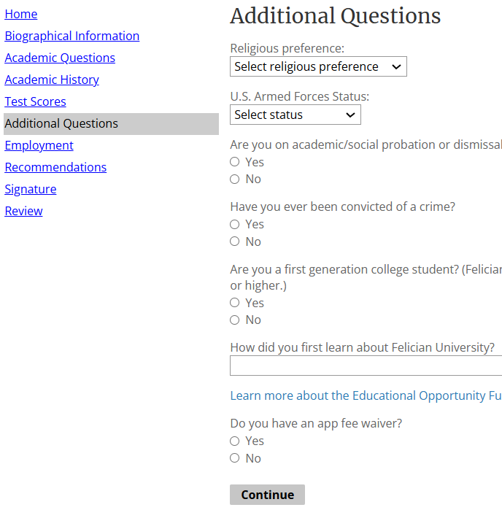

- Fill out the Employment section, and then Continue:
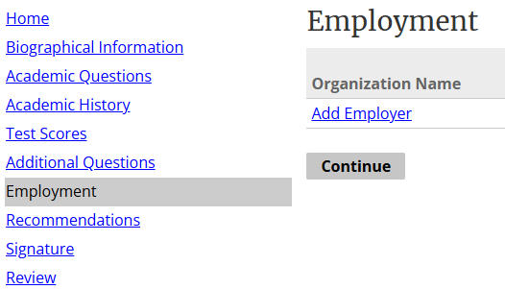

- Fill out the Recommendations section, and then Continue (not required for all programs):
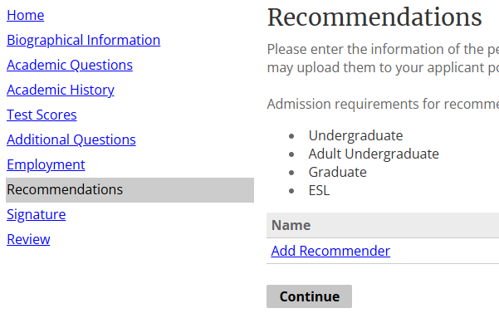

- Sign your application, and then Continue:
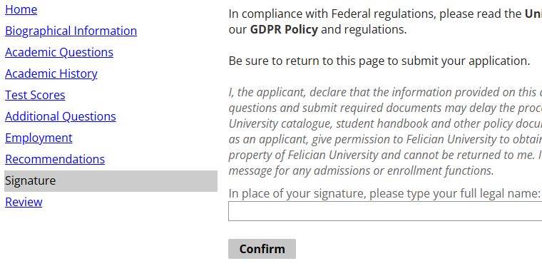

- Review & Submit your application

